SIMATS ENGINEERING (SAVEETHA SCHOOL OF ENGINEERING)
Department of Computer Science and Engineering
CO1 ASSESSMENT TOOL 1 – Case Study Analysis
Course Code: | CSA1001 | Course Title: | Software Engineering
CO Assessed: | CO1 | Assessment: | Assessment Tool 1 – Case Study Analysis
Weightage: | 20% | Total Marks: | 25
CO1 Statement: | Apply advanced methodologies and agile project management techniques to manage software projects effectively
Student Name: | Dhanush S | Reg. No.: | 192511180
Date: | 03-10-2026 | Duration: | 60 minutes

Code of Conduct
I Jai Ganesh Rao N/ 192524073 certify that this submission is my original work and that I have adhered to the guidelines specified for this assessment. I understand that any violation of academic integrity rules will result in disciplinary action.
Signature of the Student: _________________________

Annexure A – Case Study Analysis
Instructions to Students:
Each student will be allotted one problem statement. Analyze the assigned problem systematically by following the steps given below. Your report should demonstrate your understanding of software engineering concepts and your ability to design an appropriate software solution.
Based on your allotted problem statement, prepare a report by answering the following questions:
Smart Grocery Consumption and Reorder Management System
- Understand the Problem Statement
1.1 Problem Explanation
Every household, hostel mess, canteen and small grocery outlet buys food and daily-use items on a regular basis, yet most of them still track what is available at home using memory, handwritten lists or last-minute checks in the kitchen. As a result, essential items such as rice, milk, cooking oil, pulses or detergent often run out unexpectedly, while other items are bought twice and are thrown away after their expiry date. Both situations waste money, time and food.
The core difficulty is that grocery consumption is continuous and irregular. The quantity used each week changes with the number of people at home, festivals, guests, seasons and eating habits. Because nobody records purchases and usage systematically, it is hard to know how much stock is left, how fast it is being used, and when the next purchase should be made.
The proposed Smart Grocery Consumption and Reorder Management System solves this by recording purchases, tracking consumption, learning usage patterns, predicting when each item will be exhausted, and recommending or placing a reorder at the right time and in the right quantity. The user stays in control by approving reorders, while the system takes care of the repetitive monitoring work.
1.2 Objectives of the Proposed System
The main objectives of the system are:
- Maintain an accurate, up-to-date digital inventory of groceries and household consumables.
- Record purchases quickly through barcode scanning, receipt upload or manual entry.
- Track daily and weekly consumption of each item for every household or store.
- Predict the date on which each item will run out using consumption history.
- Generate automatic reorder suggestions with a recommended quantity and preferred vendor.
- Alert users about low stock, items nearing expiry and unusual consumption.
- Reduce food wastage and over-buying, and help users stay within a monthly budget.
- Integrate with online grocery vendors and payment services to complete orders.
- Provide dashboards and reports on consumption trends, spending and wastage.
- Protect user data through secure authentication, encryption and access control.
1.3 Scope of the Problem
The system is intended for households, shared residences, small shops and institutional kitchens that need regular stock monitoring of groceries. The scope of the project covers the following areas:
- User and household registration with multiple members per household.
- Grocery inventory management with categories, units, quantity and expiry dates.
- Purchase capture and consumption recording.
- Consumption analysis and AI-based demand prediction.
- Reorder rule configuration, shopping-list generation and order placement.
- Expiry, wastage and low-stock alerts through app, SMS or email.
- Budget tracking, dashboards, reports and data export.
The scope does not include running a delivery service, manufacturing or warehouse-level supply chain management for large retailers, or nutritional and medical diet planning. These can be added later as separate modules.

- Identify Key Stakeholders and Challenges
2.1 Stakeholders and Their Roles and Responsibilities
Several groups interact with or are affected by the system. The table below lists each stakeholder, explains what the stakeholder does in relation to the system, and summarises the main difficulty that the stakeholder faces today.
Stakeholder | Role and Responsibilities | Major Challenges
Household Users / Customers | Register items, record purchases and usage, approve reorder suggestions and set budgets. | Forgetting to note usage, running out of items, buying duplicates and wasting food.
Family Members / Shared Users | Update consumption, add items to the shared list and respond to alerts. | Inconsistent updates by different members and conflicting purchase decisions.
Store Managers / Canteen Staff | Monitor bulk stock, manage reorder levels and plan weekly purchases for many consumers. | High volume of items, sudden demand changes and stock-outs during peak days.
Grocery Vendors / Suppliers | Provide product catalogue, prices and availability, and accept and fulfil orders through APIs. | Different data formats, price changes, stock unavailability and order mismatches.
Delivery Partners | Deliver confirmed orders to the customer on the chosen date and time slot. | Delivery delays, wrong address details and failed deliveries.
Payment Service Providers | Process online payments securely and confirm transaction status. | Payment failures, fraud risk and compliance requirements.
System Administrators | Manage user accounts, monitor system health, take backups and apply security updates. | Maintaining uptime, data security and handling growth in users.
Development and Data Science Team | Design, build, test and improve the application and prediction models. | Changing requirements, limited early data for training and model accuracy.

2.2 Major Challenges and Issues
Beyond the stakeholder-specific difficulties above, the following issues affect the system as a whole and must be handled in the design:
1. Irregular consumption patterns
Usage changes with guests, festivals, seasons and travel, so a fixed reorder schedule often fails.
2. Manual and incomplete data entry
Users forget to record purchases or usage, which makes the inventory inaccurate over time.
3. Product diversity
Items differ in units (kg, litre, packets), pack sizes and brands, which complicates comparison and tracking.
4. Perishable items and expiry
Fresh and packaged foods expire at different rates, so wrongly timed reorders lead directly to wastage.
5. Cold-start problem for prediction
A new user has no history, so early predictions are weak and must rely on default values until data accumulates.
6. Vendor and price variation
Prices, offers and stock levels vary between vendors and change frequently.
7. Privacy and security
Purchase history reveals household habits and payment details, so personal data must be strongly protected.
8. User trust and control
Users may not accept fully automatic purchases, so the system must always allow review and approval.
- Analyze the Current Approach
3.1 Existing System / Current Process
At present, most people manage groceries manually. A family member checks the kitchen shelves, writes a list on paper or in a phone note, visits a nearby store or orders from a shopping app, and repeats the process every few days or weeks. Stock levels are judged by eye, and consumption is estimated from memory. Shopping apps such as online supermarkets only show the products and past orders; they do not tell the user how much is still available at home or when it will finish.
Small shops and canteens follow a similar pattern using notebooks, spreadsheets or simple billing software. The owner decides the reorder quantity based on experience, and mistakes are usually noticed only after an item has already finished.
3.2 Strengths of the Current Approach
- It is simple and needs no training, technology or extra cost.
- Experienced users can judge quality, freshness and brand preference well.
- Shopping apps already provide convenient ordering, offers and home delivery.
- Flexible decisions are possible, such as buying extra for guests or festivals.
- Personal control over every purchase prevents unwanted automatic orders.

3.3 Limitations of the Current Approach
- No real-time view of what is available at home or in the store.
- Stock-outs of essential items and duplicate purchases are common.
- Expiry dates are overlooked, causing food wastage.
- Consumption is not recorded, so trends and future needs cannot be estimated.
- Lists and orders are scattered across notes, bills and different apps.
- No budget visibility or comparison across months.
- Shared households face confusion about who bought what.

3.4 Gap Analysis
The comparison below shows the gaps in the present process and how the proposed system is intended to fill each one.
Gap in Current Process | Impact | Proposed System Response
No central digital inventory | Users do not know actual stock | Single inventory updated on every purchase and usage entry
No usage tracking or forecasting | Items finish unexpectedly | Consumption history with AI-based run-out prediction
Reordering done manually | Delays, forgotten items, impulse buying | Rule-based and predicted reorder suggestions with one-tap approval
Expiry not monitored | Food wastage and money loss | Expiry alerts and use-first-expiring-first suggestions
No analytics or budget view | Overspending goes unnoticed | Dashboards for spending, wastage and trends

The major gap, therefore, is the absence of a single integrated platform that connects inventory, consumption, prediction and ordering. The proposed system is designed to provide exactly this.

- Propose a Suitable Solution Using Software Engineering Principles
4.1 Proposed Solution and System Architecture
The proposed solution is a web and mobile based Smart Grocery Consumption and Reorder Management System. It follows a layered architecture so that each layer has one clear responsibility. Users interact through the presentation layer, every request passes through the API gateway and security layer, the business modules perform the real work, and the data layer stores inventory, consumption history and models. External services such as grocery vendors, payment gateways and OCR are connected through well-defined APIs.
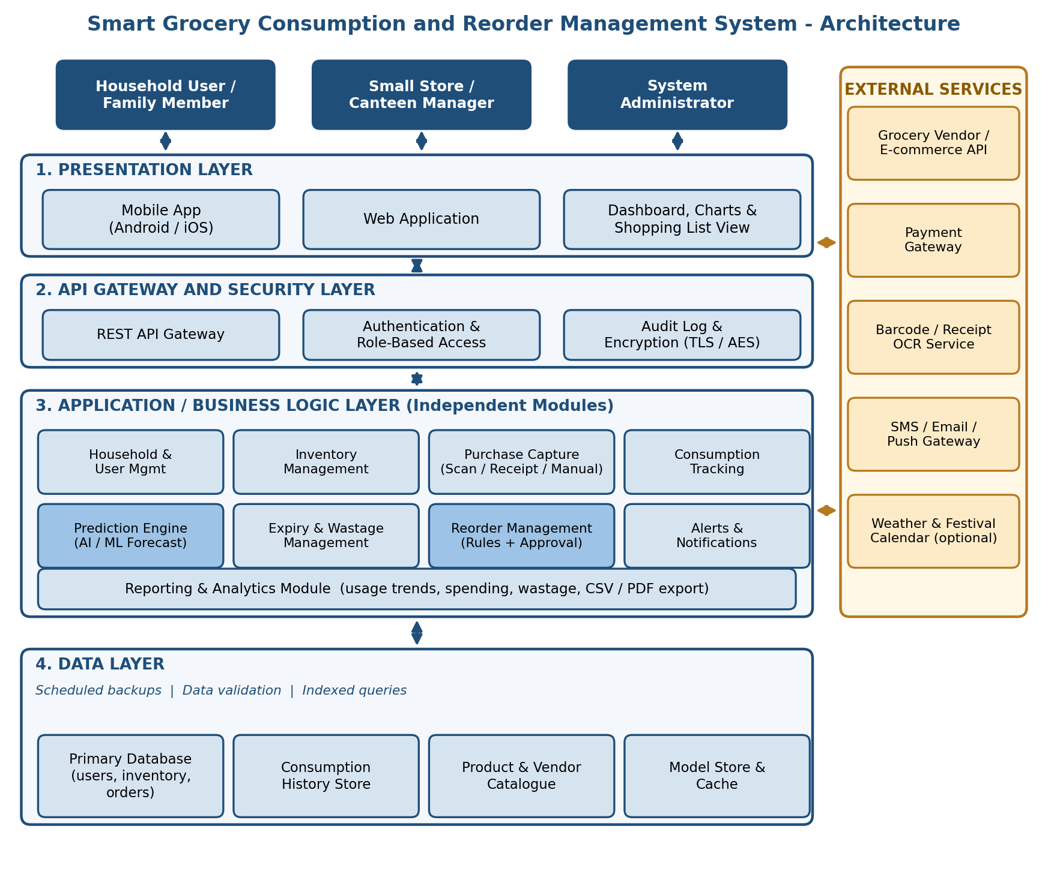
Figure 4.1: Architecture block diagram of the proposed system
In this design, the Prediction Engine reads consumption history from the data layer and estimates the remaining days of stock for every item. The Reorder Management module compares this estimate with the vendor lead time and the minimum stock level, and then creates a suggested order. The Alerts and Notifications module informs the user, and after approval the order is sent to the selected vendor and paid through the payment gateway. Every action is written to the audit log for traceability.

4.2 Major Functional Modules

- Household and User Management – Registration, login, household creation, member roles and preferences.
- Inventory Management – Add, edit and delete items with category, unit, quantity, brand, price and expiry date.
- Purchase Capture – Record purchases by barcode scan, receipt upload with OCR or manual entry.
- Consumption Tracking – Log daily usage and automatically reduce stock; support quick entries such as “used 1 kg rice”.
- Prediction Engine (AI/ML) – Forecast item-wise demand and run-out dates using moving averages and time-series models.
- Expiry and Wastage Management – Track expiry dates, flag items to be used first and record discarded quantities.
- Reorder Management – Apply minimum-stock rules and predictions to build a shopping list with recommended quantities.
- Vendor and Order Integration – Compare vendors, place orders, track status and confirm deliveries.
- Alerts and Notifications – Send low-stock, expiry, price-drop and order-status messages by push, SMS or email.
- Reporting and Analytics – Dashboards and exportable reports for consumption, spending and wastage.

ID | Requirement
FR1 | The system shall allow users to register, log in and create or join a household.
FR2 | The system shall maintain an inventory of items with quantity, unit and expiry date.
FR3 | The system shall record purchases through barcode, receipt or manual input.
FR4 | The system shall record consumption and update the stock automatically.
FR5 | The system shall predict the run-out date of each item and show a confidence indicator.
FR6 | The system shall generate reorder suggestions based on minimum stock levels and predictions.
FR7 | The system shall let the user edit, approve or reject a suggested order before it is placed.
FR8 | The system shall place orders with integrated vendors and track their status.
FR9 | The system shall send alerts for low stock, near-expiry items and order updates.
FR10 | The system shall provide dashboards, budget tracking and CSV/PDF export of reports.

4.4 Non-Functional Requirements

- Security – Password hashing, role-based access, encrypted communication and storage, and audit logs.
- Performance – Dashboard and inventory screens should load within about 3 seconds under normal load.
- Scalability – Support a growing number of households, items and orders without redesign.
- Reliability and Availability – Regular backups, error handling and target uptime of at least 99%.
- Usability – Simple screens, minimal typing, support for local languages and accessible design.
- Maintainability – Modular code, documentation and automated tests for easy changes.
- Interoperability – Standard REST/JSON interfaces for vendor, payment and notification services.
- Accuracy – Prediction quality is monitored, and users can correct values to improve future forecasts.

4.5 Incorporation of Software Engineering Principles
The solution is planned with core software engineering principles so that the final product is easy to build, extend and trust.

4.3 Functional Requirments

Principle | How it is incorporated in the solution
Modularity | The system is divided into independent modules (inventory, prediction, reorder, alerts, reporting) with defined interfaces, so each can be developed and tested separately.
Scalability | Stateless application services, an API gateway and an indexed database allow more servers and users to be added; prediction jobs run in the background.
Maintainability | Separation of concerns, coding standards, version control and automated tests allow a module to be corrected or replaced without affecting the others.
Reliability | Input validation, exception handling, transaction-safe order placement, scheduled backups and retry mechanisms for vendor APIs keep data consistent.
Usability | Barcode scan, one-tap approval, clear dashboards and meaningful alerts reduce the effort needed from users; feedback is collected in every sprint.
Security | Authentication, role-based access, TLS and AES encryption, secure payment through a gateway, audit logs and privacy-by-design for personal data.

- Justify the Chosen Methodology/Framework
5.1 Selected Methodology: Agile (Scrum)
The Agile Scrum framework is selected for developing this system. Scrum works in short iterations called sprints, usually of two weeks, at the end of which a working increment of the software is delivered and reviewed. A product owner maintains a prioritised backlog, the development team builds the selected items, and a Scrum Master ensures that the process is followed.

The project is planned in six sprints, as shown below.
Sprint | Focus | Key Deliverables
Sprint 1 | Core platform | User registration and login, household setup, database design, basic inventory screens
Sprint 2 | Purchase and consumption | Barcode and manual purchase entry, consumption logging, stock updates, expiry tracking
Sprint 3 | Reorder management | Minimum-stock rules, shopping list generation, user approval workflow, alerts
Sprint 4 | Prediction engine | Consumption analysis, run-out forecasting, confidence score, seasonal adjustment
Sprint 5 | Integration and reporting | Vendor and payment API integration, order tracking, dashboards, CSV/PDF export
Sprint 6 | Testing and release | Functional, integration, security, performance and user acceptance testing; deployment

5.2 Why Agile Is Suitable
The requirements of this system are not fully known at the start. Users may want new alert types, different vendors or better prediction behaviour only after they see the first working version. A plan-driven model such as Waterfall would fix all requirements at the beginning and would make later changes costly. Agile, in contrast, welcomes change and delivers value early.
- Incremental delivery – Useful features such as inventory and alerts are available from the early sprints.
- Continuous user feedback – Households and store managers can review each sprint and guide the next one.
- Risk reduction – The uncertain parts (prediction accuracy and vendor integration) are tested early and improved step by step.
- Flexibility – Backlog priorities can be changed when vendor policies or user needs change.
5.3 Support for Successful Development and Maintenance
Agile supports the full life of the product, not only the first release. Daily stand-up meetings keep the team aligned, sprint reviews confirm that the software matches user needs, and retrospectives help the team improve its way of working. Continuous integration with automated testing keeps the code stable after every change.
After release, the same backlog-based approach is used for maintenance. Bug fixes, new vendor connectors and model improvements are prioritised and delivered in small updates, and the modular architecture ensures that these updates do not disturb the rest of the system. This makes long-term maintenance predictable and low-risk.

Discuss Expected Outcomes and Limitations
6.1 Expected Benefits
When implemented, the system is expected to change grocery management from a reactive habit into a planned and data-driven activity. The expected benefits are:
- Fewer stock-outs of essential items.
- Lower food wastage through expiry alerts and use-first suggestions.
- Reduced duplicate purchases and better control of the monthly grocery budget.
- Time saved through automatic shopping lists and one-tap reordering.
- Clear visibility of consumption trends for each item and each household.
- Better coordination among family members or store staff using a shared inventory.
- Improved planning for stores and canteens through demand forecasting.
6.2 How the Solution Addresses the Identified Challenges
Challenge | How the Proposed Solution Addresses It
Irregular consumption | Prediction engine learns patterns and adjusts for season, festivals and household size.
Manual, incomplete data entry | Barcode scan, receipt OCR and quick-entry options reduce effort; reminders prompt users to update.
Perishable items | Expiry tracking, alerts and quantity recommendations based on shelf life.
Cold-start problem | Category-wise default consumption rates are used until enough personal history is available.
Vendor and price variation | Vendor comparison and API integration provide current price and availability.
Privacy and security | Encryption, role-based access, audit logs and minimal data collection.
User trust and control | Every automatic suggestion requires approval unless the user enables auto-order.

6.3 Potential Risks, Implementation Challenges and Limitations
1. Prediction accuracy
Forecasts depend on good data; sudden changes in lifestyle can cause wrong estimates.
2. User discipline
If users stop recording usage, the stock figures become inaccurate and the system loses value.
3. Third-party dependency
Vendor or payment API downtime, changes or policy restrictions can affect ordering.
4. Barcode and OCR errors
Poor receipts, local products without barcodes or unclear images may produce incorrect entries.
5. Data privacy risk
The stored purchase history is sensitive, so a security breach would harm users.
6. Cost and adoption
Development, hosting and awareness effort are needed, and some users may prefer the manual method.
7. Connectivity
The app needs internet access for ordering and synchronisation, which may be limited in some areas.
These risks are reduced through early prototyping, user training, fallback manual entry, secure development practices and regular monitoring of model performance.
6.4 Future Enhancements
Once the core system is stable, the following improvements can be introduced to make it smarter and more convenient:
- IoT smart shelves and smart containers to measure stock automatically.
- Voice assistant support for adding items and logging usage.
- Recipe and meal-plan based consumption forecasting.
- Price-prediction and best-time-to-buy suggestions across vendors.
- Computer-vision based scanning of refrigerator and shelf photos.
- Multi-language interface and offline mode.
- Community sharing of surplus food and donation of near-expiry items.
- Integration with smart-home and wearable devices.

Rubrics for Calculation
Criteria | Excellent (5 Marks) | Good (3 Marks) | Satisfactory (2 Marks) | Needs Improvement (1 Mark)
Problem Understanding (30%) | Clearly explains the problem, objectives, and scope with complete understanding. | Explains the problem with minor omissions. | Basic understanding with limited explanation. | Poor understanding; objectives and scope are unclear or missing.
Stakeholder & Challenge Analysis (25%) | Identifies all stakeholders, their roles, and challenges with clear analysis. | Identifies most stakeholders and challenges with adequate analysis. | Identifies only a few stakeholders or challenges. | Stakeholders and system analysis are incomplete or inaccurate.
Current System Analysis (20%) | Thoroughly analyzes the existing system, strengths, weaknesses, and identifies all gaps. | Good analysis with most strengths and weaknesses identified. | Limited analysis with partial identification of issues. | Proposed solution is unclear or inappropriate; requirements are largely missing.
Proposed Software Solution & Software Engineering Principles (15%) | Proposes an innovative, feasible solution applying appropriate software engineering principles (modularity, scalability, maintainability, security, etc.). | Suitable solution with good application of software engineering principles. | Basic solution with limited application of software engineering principles. | Methodology is inappropriate, poorly justified, or not discussed.
Methodology/ Framework Justification (10%) | Selects the most suitable SDLC/model/framework and provides strong technical justification. | Suitable methodology selected with adequate justification. | Methodology selected but justification is weak. | Outcomes, limitations, or future enhancements are missing; report lacks organization and clarity.

Criteria | Mark
Problem Understanding (30%) | /5
Stakeholder & Challenge Analysis (25%) | /5
Current System Analysis (20%) | /5
Proposed Software Solution & Software Engineering Principles (15%) | /5
Methodology/ Framework Justification (10%) | /5
TOTAL | /25

